Employment Rate: 2006 -2016 TVET Graduates

Survey Round | TVET Graduates Covered | Not Indicated | Not in the Labor Force | In the Labor Force |  |  |  | Total Graduates
 |  |  |  | Not Employed | Employed | Total | ER
2008 | CY 2006 |  | 39,973 | 79,514 | 97,453 | 176,967 | 55.1 | 216,940
2011 | CY 2009 | 46,328 | 146,045 | 220,359 | 342,510 | 562,869 | 60.9 | 755,242
2012 | CY 2011 |  | 171,203 | 148,268 | 241,559 | 389,827 | 62.0 | 561,030
2013 | CY 2010 |  | 143,768 | 135,936 | 263,119 | 399,055 | 65.9 | 542,823
 | CY 2012 |  | 256,072 | 184,556 | 347,811 | 532,367 | 65.3 | 788,439
2014 | CY 2013 |  | 312,648 | 240,239 | 454,095 | 694,335 | 65.4 | 1,006,983
2015 | CY 2014 |  | 415,362 | 272,546 | 533,874 | 806,419 | 66.2 | 1,221,781
2017 | CY 2016 |  | 607,276 | 281,069 | 718,277 | 999,346 | 71.87 | 1,606,622
Sources: Impact Evaluation Study of TVET Programs (2008, 2011, 2012, 2013)
Study on the Employability of TVET Graduates (2014, 2015, 2017)

Employment Rate by Region: 2009 – 2016 TVET Graduates

Region | CY 2009 | CY 2010 | CY 2011 | CY 2012 | CY 2013 | CY 2014 | CY 2016
NCR | 56.6 | 60.8 | 63.1 | 56.5 | 71.2 | 76.1 | 76.5
CAR | 82.8 | 63.4 | 73.2 | 62.5 | 71.6 | 61.8 | 82.8
Region 1 | 67.6 | 71.5 | 54.8 | 71.1 | 72.6 | 58.7 | 83.1
Region 2 | 69.7 | 76.6 | 62.6 | 78.4 | 85.3 | 70.2 | 75.3
Region 3 | 60.2 | 61.0 | 71.1 | 58.7 | 65.1 | 94.2 | 66.9
Region 4A | 52.0 | 62.4 | 77.6 | 65.5 | 61.7 | 49.6 | 66.4
Region 4B | 71.4 | 81.4 | 67.8 | 71.3 | 70.2 | 62.2 | 81.5
Region 5 | 68.4 | 67.7 | 47.6 | 71.0 | 64.2 | 57.4 | 78.7
Region 6 | 56.1 | 76.9 | 66.9 | 82.2 | 79.7 | 80.6 | 71.5
Region 7 | 74.1 | 75.7 | 66.7 | 72.1 | 47.6 | 67.3 | 65.9
Region 8 | 63.1 | 73.7 | 80.2 | 67.0 | 64.2 | 62.0 | 62.1
Region 9 | 61.1 | 68.1 | 77.8 | 67.4 | 53.5 | 61.2 | 62.4
Region 10 | 61.9 | 65.1 | 82.3 | 68.7 | 67.9 | 51.0 | 70.7
Region 11 | 64.5 | 58.8 | 73.4 | 67.3 | 65.8 | 65.1 | 95.8
Region 12 | 68.1 | 72.0 | 46.8 | 76.1 | 70.6 | 59.6 | 57.2
CARAGA | 61.3 | 76.0 | 54.1 | 74.7 | 61.8 | 58.2 | 74.9
ARMM | 46.8 | 30.7 | 37.0 | 21.2 | 31.8 | 34.2 | 52.8
National ER | 60.9 | 65.9 | 62.0 | 65.3 | 65.4 | 66.2 | 71.9

Employment Rate by Sex: 2009 - 2014 TVET Graduates

Survey Round | Coverage: | Male |  | Female |  | Total | National Employment Rate
 | Year Graduates | Employed | Employment Rate | Employed | Employment Rate
2011 | 2009 | 206,773 | 62.7 | 135,737 | 58.2 | 342,510 | 60.9
2013 | 2010 | 143,729 | 66.9 | 119,390 | 64.8 | 263,119 | 65.9
2012 | 2011 | 136,831 | 63.6 | 104,728 | 60.0 | 241,559 | 62.0
2013 | 2012 | 178,625 | 65.8 | 169,186 | 64.8 | 347,811 | 65.3
2014 | 2013 | 244,527 | 65.6 | 209,569 | 65.2 | 454,096 | 65.4
2015 | 2014 | 269,811 | 67.5 | 264,063 | 65.0 | 533,874 | 66.2
2017 | 2016 | 349,919 | 72.2 | 368,358 | 71.5 | 718,277 | 71.9

Employment Rate by Delivery Mode: 2009 - 2014 TVET Graduates

Survey Round | Coverage: | National Employment Rate | Employment Rate By Delivery Mode
 | CY Graduates |  | Institution-based | Community-based | Enterprise-based
2005 | 2004 | 48.7 | * | 49.7 | 54.1
2008 | 2006 | 44.9 | ** | ** | 46.6
2011 | 2009 | 60.9 | 61.1 | 56.4 | 83.1
2013 | 2010 | 65.9 | 65.4 | 66.3 | 69.7
2012 | 2011 | 62.0 | 59.9 | 64.5 | 68.7
2013 | 2012 | 65.3 | 62.1 | 72.5 | 72.1
2014 | 2013 | 65.4 | 65.6 | 67.9 | 52.2
2015 | 2014 | 66.2 | 64.2 | 69.9 | 67.4
2017 | 2016 | 71.9 | 73.2 | 70.0 | 71.5
Notes:
* 2005 IES: School-based = 46.4%; Center-based = 48.8%
** 2008 IES: School-based = 47.0%; Center-based = 39.2%; Community-based programs - not included

Employment Rate of TVET Graduates (In the Labor Force) with Certificates (NC/CoC)

Survey Round | TVET Graduates Covered | Total Certified Graduates  (covered by the surveys) | Employment Rate
2013 | CY 2010 | 229,451 | 69.8
 | CY 2012 | 368,655 | 66.7
2014 | CY 2013 | 451,379 | 66.4
2015 | CY 2014 | 577,301 | 68.0
2017 | CY 2016 | 831,352 | 74.2
Sources: Impact Evaluation Study of TVET Programs (2013)
Study on the Employability of TVET Graduates (2014, 2015, 2017)

Employment Rate of TVET Graduates by Sector

Sector | CY 2009 | CY 2010 | CY 2011 | CY 2012 | CY 2013 | CY 2014 | CY 2016
Agriculture and Fishery | 59.5 | 82.2 | 86.3 | 77.3 | 73.4 | 79.1 | 80.45
Automotive and Land Transportation |  | 73.2 | 70.2 | 70.0 | 67.6 | 70.5 | 73.60
Construction | 67.0 | 70.3 | 71.1 | 77.9 | 70.6 | 66.8 | 73.50
Electronics | 63.4 | 61.2 | 57.5 | 63.1 | 62.8 | 61.1 | 71.13
Footwear and Leather goods |  |  | 62.8 | 81.5 | 28.7 | 100.0 | 81.74
Furniture And Fixtures |  | 100.0 | 56.6 | 70.1 | 45.3 | 55.2 | 100.0
Garments | 74.3 | 72.7 | 67.6 | 78.8 | 66.4 | 71.6 | 77.13
Health, Social and Other Community Development Services | 64.7 | 67.0 | 73.2 | 71.2 | 70.1
Human Health/Health Care |  |  |  |  |  | 67.9 | 68.03
Social, Community Development and Other Services |  |  |  |  |  | 72.5 | 71.63
Heating, Ventilation, Air-conditioning and Refrigeration (HVAC) | 69.5 | 69.7 | 53.5 | 72.6 | 62.7 | 70.5 | 72.42
Information and Communication Technology | 59.6 | 62.9 | 57.5 | 58.4 | 62.7 | 61.3 | 69.10
Maritime | 38.3 | 58.4 | 50.2 | 59.8 | 62.6 | 35.6 | 72.99
Metals and Engineering | 64.3 | 76.0 | 71.8 | 71.9 | 63.7 | 69.1 | 72.94
Processed Food and Beverages | 71.5 | 78.3 | 75.8 | 70.1 | 60.5 | 71.4 | 70.15
Tourism | 54.8 | 60.3 | 50.6 | 58.9 | 61.8 | 59.8 | 69.90
TVET | 67.5 | 100.0 | 87.0 | 90.0 | 96.3 | 95.5 | 95.65
Decorative Crafts |  | 67.3 | 54.8 | 73.5 | 71.7 | 49.9 | 100.0
Wholesale and Retail Trading | 87.8 | 67.5 | 60.5 | 80.8 | 27.0 |  | 53.96
Language | 68.0 |  |  | 70.7 | 72.6 | 52.2 | 78.54
Entrepreneurship |  |  |  |  | 68.2 | 72.3 | 81.74
Livelihood | 52.8 | 57.7 | 64.9 | 66.3 | 60.6 | 76.5
Visual Arts |  |  |  |  | 100.0
Utilities |  | 100.0 | 30.1 | 100.0 |  | 77.9
Logistics |  |  |  |  |  |  | 100.0
Automotive | 65.2
Land Transport | 72.8
Aircraft | 19.4 | 70.2 |  | 50.3
Manufacturing |  |  |  | 51.6
Others |  | 57.9 | 55.4 | 83.7 |  | 77.9 | 67.20
Not indicated | 46.2
National Employment Rate | 60.9 | 65.9 | 62.0 | 65.3 | 65.4 | 66.2 | 71.9

Percentage Distribution of Employed TVET Graduates by Class of Worker

Class of Worker | CY 2009 | CY 2010 | CY 2011 | CY 2012 | CY 2013 | CY 2014 | CY 2016
Wage and Salary Workers | 84.3 | 81.9 | 74.5 | 85.6 | 79.5 | 76.4 | 75.10
Private household | 9.7 | 9.4 | 7.4 | 9.6 | 8.9 | 53.1 | 4.89
Private establishment | 63.1 | 61.8 | 53.3 | 63.1 | 57.7 | 6.4 | 51.7
Government/GOCC | 8.58 | 7.8 | 9.5 | 9.9 | 9.4 | 14.2 | 16.8
Employed in family operated farm or business | 2.6 | 2.9 | 4.4 | 3.0 | 3.6 | 2.7 | 2.7
Own account workers | 11.9 | 4.9 | 19.9 | 12.2 | 18.9 | 21.7 | 24.2
Self-employed | 9.0 | 5.4 | 16.4 | 7.4 | 16.2 | 18.3 | 22.1
Employer in family-operated farm or business | 2.9 | 4.9 | 3.5 | 4.7 | 2.7 | 3.4 | 2.08
Unpaid family worker | 0.8 | 1.9 | 2.8 | 2.1 | 1.6 | 1.9 | 0.69
Not indicated | 3.0 | 5.9 |  | 0.2
Total Employed Graduates | 342,510 | 263,119 | 241,559 | 347,811 | 454,095 | 533,874 | 718,277

Employment Rate: 2009 - 2014 TVET Scholars

Year | Scholarship Programs | Not in the Labor Force | In the Labor Force |  |  |  | Total Scholars
 |  |  | Not Employed | Employed | Total | ER
2009
 | TWSP |  | 137,580 | 220,094 | 357,674 | 61.5
 | PESFA |  | 1,464 | 1,613 | 3,077 | 52.4
 | LEP |  | 1,021 | 1,307 | 2,328 | 56.1
 | Others |  | 2,762 | 7,295 | 10,057 | 72.1
 | Total |  | 142,827 | 230,309 | 373,136 | 61.7
 | TVET Total | 146,045 | 220,359 | 342,510 | 562,869 | 60.9 | 755,242
 | - 46,328 – did not indicate after-training job hunt status
2010
 | TWSP | 9,300 | 8,078 | 17,509 | 25,587 | 68.4 | 34,887
 | PESFA | 4,070 | 4,176 | 7,638 | 11,814 | 64.7 | 15,884
 | Others | 12,645 | 11,667 | 27,190 | 38,858 | 70.0 | 51,502
 | Total | 26,015 | 23,921 | 52,337 | 76,258 | 68.6 | 102,273
 | TVET Total | 143,768 | 135,936 | 263,119 | 399,055 | 65.9 | 542,823
2011
 | TWSP
 | PESFA
 | Others
 | Total
 | TVET Total
2012
 | TWSP | 35,008 | 31,838 | 69,115 | 100,953 | 68.5 | 135,961
 | PESFA | 7,135 | 6,956 | 10,444 | 17,399 | 60.0 | 24,535
 | Others | 24,765 | 16,087 | 37,991 | 54,079 | 70.3 | 78,844
 | Total | 66,908 | 54,882 | 117,550 | 172,432 | 68.2 | 239,339
 | TVET Total | 256,072 | 184,556 | 347,811 | 532,367 | 65.3 | 788,439
2013
 | TWSP | 34,399 | 33,632 | 86,095 | 119,727 | 71.9 | 154,126
 | PESFA | 7,069 | 7,676 | 9,982 | 17,657 | 56.5 | 24,726
 | Others | 34,666 | 26,998 | 55,782 | 82,780 | 67.4 | 117,446
 | Total | 76,134 | 68,306 | 151,859 | 220,164 | 69.0 | 296,298
 | TVET Total | 312,648 | 240,239 | 454,095 | 694,335 | 65.4 | 1,006,983
2014
 | TWSP | 31,264 | 44,754 | 85,642 | 130,396 | 65.7 | 161,660
 | STEP | 4,343 | 3,892 | 11,153 | 15,046 | 74.1 | 19,388
 | PESFA | 8,344 | 8,082 | 11,583 | 19,664 | 58.9 | 28,008
 | Others | 20,891 | 18,173 | 43,248 | 61,422 | 70.4 | 82,313
 | Total | 64,842 | 74,901 | 151,627 | 226,528 | 66.9 | 291,370
 | TVET Total | 415,362 | 272,546 | 533,874 | 806,419 | 66.2 | 1,221,781

Employment Rate: 2009 - 2016 TVET Scholars (continued …)

2016
 | TWSP | 68,137 | 42,929 | 143,187 | 186,116 | 76.93 | 254,253
 | STEP | 17,468 | 6,517 | 22,304 | 28,821 | 77.39 | 254,253
 | PESFA | 7,249 | 6,153 | 12,040 | 18,193 | 66.18 | 46,289
 | Others | 49,178 | 31,675 | 91,751 | 123,426 | 74.34 | 172,604
 | Not indicated | 2,855 | 1,591 | 5,280 | 6,870 | 76.85 | 9,725
 | Total | 144,887 | 88,865 | 274,561 | 363,426 | 75.55 | 508,313
 | TVET Total | 607,276 | 281,069 | 718,277 | 999,346 | 71.87 | 1,606,622

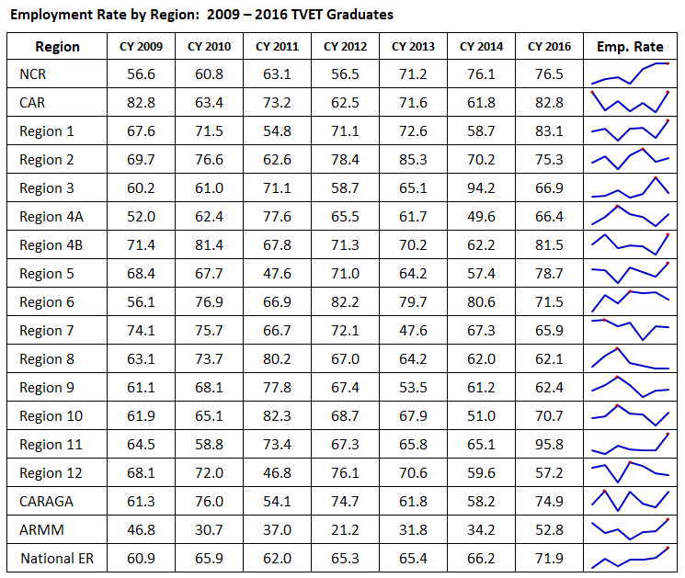

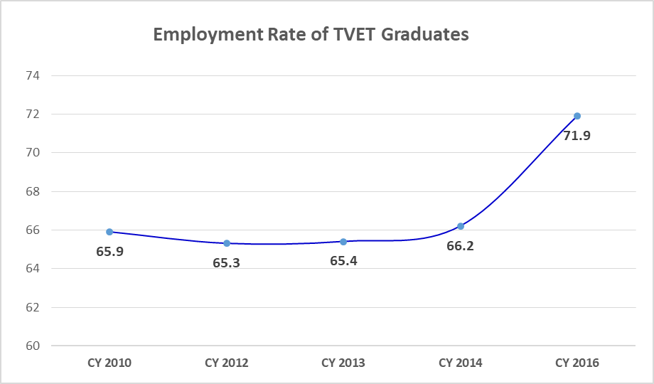

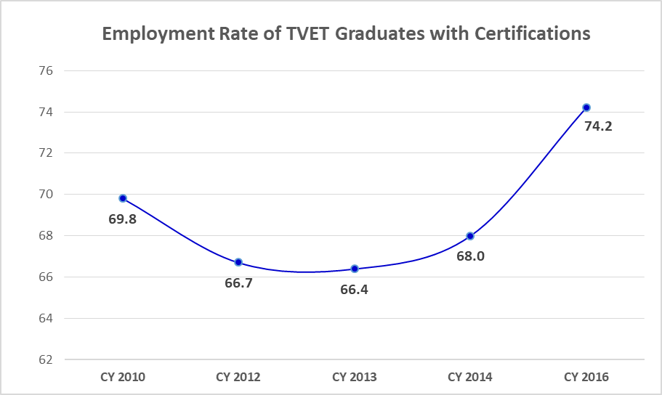

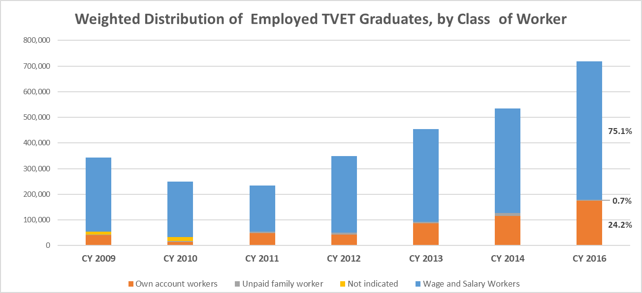

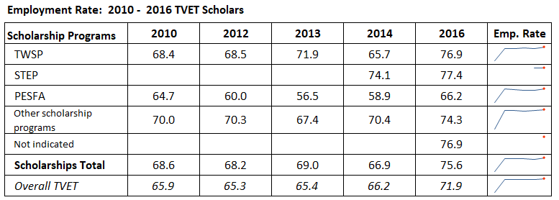

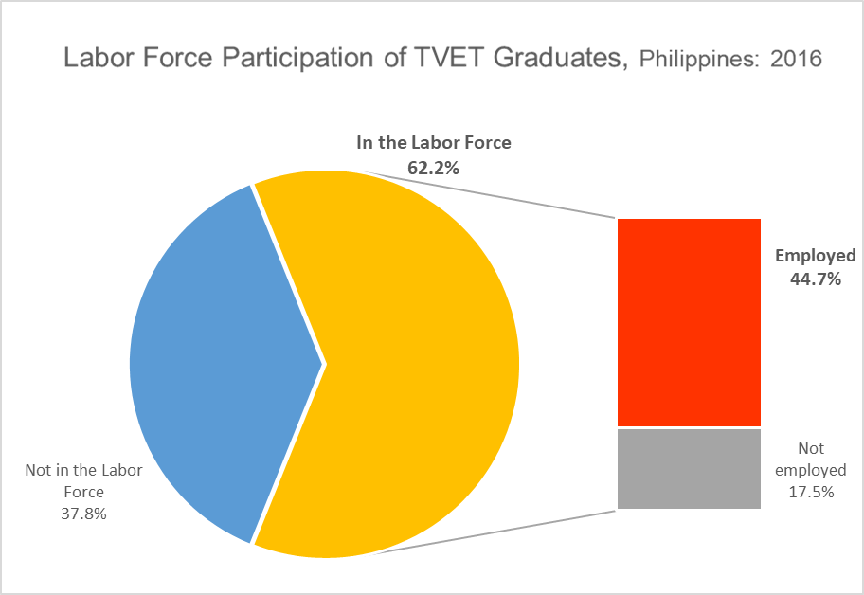

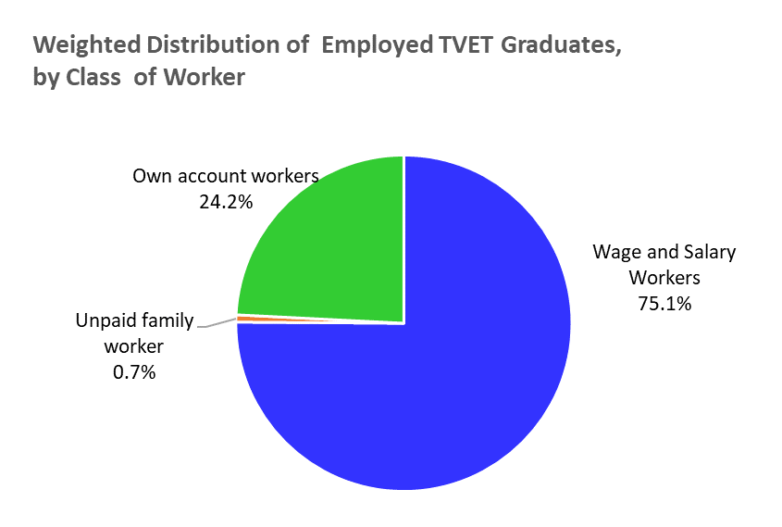

Employment Rate: 2006 -2014 TVET Graduates

Survey Round | TVET Graduates Covered | Not Indicated | Not in the Labor Force | In the Labor Force |  |  |  | LFPR  (LF/Grads) | Total Graduates | EWgR  (E/Grads)
 |  |  |  | Not Employed | Employed | Total | ER
2008 | CY 2006 |  | 39,973 | 79,514 | 97,453 | 176,967 | 55.1 | 81.6 | 216,940
2011 | CY 2009 | 46,328 | 146,045 | 220,359 | 342,510 | 562,869 | 60.9 | 74.5 | 755,242
2012 | CY 2011 |  | 171,203 | 148,268 | 241,559 | 389,827 | 62.0 | 69.5 | 561,030 | 43.11
2013 | CY 2010 |  | 143,768 | 135,936 | 263,119 | 399,055 | 65.9 | 73.5 | 542,823 | 48.56
 | CY 2012 |  | 256,072 | 184,556 | 347,811 | 532,367 | 65.3 | 67.5 | 788,439 | 44.19
2014 | CY 2013 |  | 312,648 | 240,239 | 454,095 | 694,335 | 65.4 | 69.0 | 1,006,983 | 45.25
2015 | CY 2014 |  | 415,362 | 272,546 | 533,874 | 806,419 | 66.2 | 66.0 | 1,221,781 | 43.92
2017 | CY 2016 |  | 607,276 | 281,069 | 718,277 | 999,346 | 71.9 | 62.2 | 1,606,622 | 44.90
Sources: Impact Evaluation Study of TVET Programs (2008, 2011, 2012, 2013)
Study on the Employability of TVET Graduates (2014, 2015, 2017)

Employment Rate of TVET Graduates (in the labor force) with Certificates (NC/CoC)

Year | Sex | Not in the Labor Force | In the Labor Force |  |  |  |  | Total Certified Graduates | EWgR  (E/Grads)
 |  |  | Not Employed | Employed | Total | ER | LFPR  (E/LF)
2010 | Female | 29,877 | 24,605 | 48,180 | 72,785 | 66.2 | 70.9 | 102,662 | 46.9
 | Male | 22,895 | 28,705 | 75,189 | 103,894 | 72.4 | 81.9 | 126,789 | 59.3
 | Total | 52,772 | 53,310 | 123,369 | 176,679 | 69.8 | 77.0 | 229,451 | 53.8
2012 | Female | 49,943 | 41,808 | 76,621 | 118,429 | 64.7 | 70.3 | 168,372 | 45.5
 | Male | 50,393 | 47,650 | 102,240 | 149,890 | 68.2 | 74.8 | 200,283 | 51.0
 | Total | 100,336 | 89,458 | 178,861 | 268,319 | 66.7 | 72.8 | 368,655 | 48.5
2013 | Female | 56,087 | 43,021 | 88,390 | 131,411 | 67.3 | 70.1 | 187,498 | 47.1
 | Male | 62,384 | 68,737 | 132,760 | 201,497 | 65.9 | 76.4 | 263,881 | 50.3
 | Total | 118,471 | 111,758 | 221,150 | 332,908 | 66.4 | 73.8 | 451,379 | 49.0
2014 | Female | 82,110 | 56,251 | 123,361 | 179,612 | 68.7 | 68.6 | 261,722 | 47.1
 | Male | 73,768 | 78,548 | 163,263 | 241,811 | 67.5 | 76.6 | 315,579 | 51.7
 | Total | 155,878 | 134,799 | 286,624 | 421,423 | 68.0 | 73.0 | 577,301 | 49.6
2016 | Female | 135,864 | 70,486 | 204,035 | 274,521 | 74.3 | 66.9 | 410,385 | 49.7
 | Male | 135,539 | 73,795 | 211,633 | 285,428 | 74.1 | 67.8 | 420,967 | 50.3
 | Total | 271,403 | 144,281 | 415,668 | 559,949 | 74.2 | 67.4 | 831,352 | 50.0
Sources: 2013 Impact Evaluation Study of TVET Programs
Study on the Employability of TVET Graduates (2014, 2015, 2017)

