

TECHNICAL EDUCATION AND SKILLS DEVELOPMENT AUTHORITY

LABOR MARKET INTELLIGENCE REPORT
maritime industry

Office of the Deputy Director General for Sectoral TVET
Planning Office
TESDA Complex, East Service Road, South Superhighway
Taguig City, Metro Manila
Tel. No. (02) 888-56-52; (02) 817-26-75; (02) 893-19-66
www.tesda.gov.ph

CODE: ST-PO 04-03-2011

CODE_________________

FOREWORD

Starting 2011, TESDA embarks on a stronger and more active partnership with the end-users of skilled human resources, the employers / industry. The employers / industry are in the best position to determine the skills / competencies required in their firms / industry at the right quantity and at the right time. This has long been articulated in the law that created the Technical Education and Skills Development Authority (TESDA), that says, “The State shall encourage active participation of various concerned sectors, particularly private enterprises, being the direct participants in and immediate beneficiaries of a trained and skilled workforce, in providing technical education and skills development opportunities.” (par. 2, Section 2, R.A. 7796).

The industry dialogues / consultations in priority sectors provide a venue / forum for a more efficient and effective labor market information system. TESDA’s response may be in the policy area, development of new or updating of Training Regulations, and capability building programs, among others. Importantly, these partnerships lead to an expanded enterprise-based training provision.

The dialogues have to be done at the national as well as at the regional or sub-national levels to take into account area-based requirements and peculiarities. The regional offices are, therefore, encouraged to actively engage the employers/ industry.

This Labor Market Intelligence Report (LMIR) on the Maritime Industry provides information on the results of the industry dialogues / consultations and the industry trends and prospects. We hope these initiatives will be useful and meaningful to our field offices and stakeholders.

The Sectoral TVET Cluster thanks our industry partners for their enthusiasm, dynamism and interest in making TVET really work in our country.

MILAGROS DAWA-HERNANDEZ, CESO I
Deputy Director General, Sectoral TVET

QUICK STAT ON MARITIME INDUSTRY

Deployment | - About 30% of the world’s merchant seafarers come from the Philippines making it the largest single supply nation to the world's merchant fleet - from luxury cruise ships to giant tankers and container ships.  - Currently, there are some 700,000 Filipino seafarers here and abroad.  - In 2009, 330,424 Filipino seafarers were deployed all over the world  - Less than 400,000 in the country are deployed in inter-ocean or domestic vessels. Some are in land-based jobs, mostly related or allied to marine engineering, sea navigation or nautical education and management, and teaching or professorial work.
Demand | - Global shortage in deck and engineering officers of 34,000 (Drewry Annual Manning Report)  - By 2012, this deficiency could number 84,000, given that the number of commercial vessels worldwide grows by about four percent annually.
Remittance | - Filipino sailors aboard foreign-flagged ocean-going vessels wired home a total of $2.461 billion in the eight months to August 2010, up $250 million or 11.31 percent of the $2.211 billion they remitted over the same period in 2009.
Accredited Sea-based Principals | - In 2009 Filipino seafarers were employed by 1,253 accredited sea-based principals.
Maritime Education | - Several years ago the Philippines had almost twice the number of maritime schools, more than the rest of the world combined. The number of schools was reduced after national evaluation process to ensure greater adherence to international standards.  - For recent graduates of maritime schools, competition for jobs is particularly fierce. Of the 25,000 ordinary and able seamen who graduate annually, only 8,000 to 10,000 find the job within a year.
Strengths | - English proficiency, hard-work habits, and proven professionalism have kept the Philippines at the forefront of the global manning industry
Threats | - The global shortage of seafarers and our inability to fill the void has prompted ship-owners to source from other countries, particularly China and India which are busy upgrading their manning capabilities. This poses a threat to our number one world position as seafarer-source.  - Retrenchment continues in global shipping, especially at management levels, according to the International Labour Organization (ILO)  - Other threats include:  - degradation of the environment;  - Rise in piracy and other transnational crimes such as human/drug-trafficking and smuggling;  - Surge in fuel prices and materials costs; and  - Falling charter rates
Quality Assurance | - To ensure the competence of Filipino seafarers, the Philippines consistently abides by international standards for the training and certification of its seafarers.  - Current policies and strategies are geared toward continuously improving quality of Philippine maritime education and training to make the hiring system responsive to the changing needs of the global shipping market. This is done through research and development, review of quality standards and upgrading of training equipment.

THE PHILIPPINE MARITIME INDUSTRY

2011 TVET PRIORITIES

The first consultation meeting on the Maritime Sector held on February 21, 2011 resulted in the identification of the initial TVET priority areas for 2011.

  - Study the possibility of harmonization, compatibility, commonality and integration between programs of TESDA and the Maritime Training Council (MTC) to create a single pool of maritime assessors (3.12) and trainers (6.09).

  - Review the Maritime Training Regulations: Able Seafaring Deck under Reg. 11/5, Able Seafaring Engine under Reg. 111/5 in time for the STCW Convention Manila Amendments’ implementation on January 1, 2012

  - Pursue LEP in the Maritime Sector in coordination with Commission on Higher Education (CHED), Department of Labor and Employment (DOLE) and the Maritime Training Council (TMC)

  - Build-up the maritime industry capability to undertake enterprise-based assessment of Filipino Seafarers.

  - Development of Training Regulation (TR) for Electro Technical Rating as required by the STCW Convention Manila Amendments

Additional TVET priority areas shall be identified and pursued as the TESDA-Industry consultation progresses.

---------------------------------------------------------------------------------------------------------------------------------

TESDA-INDUSTRY CONSULTATIONS AT THE REGIONAL LEVEL

All regions are encouraged to initiate the conduct of regular industry consultations/dialogue with their respective industry partners and stakeholders. The TESDA-Industry consultations shall be the venue for more established and strengthened industry collaboration/linkages in the area of labor market information, standards setting, assessment and certification, enterprise-based training and training delivery arrangements and capability building.

The proposed process flow/agenda for the initial consultation/dialogue indicated below maybe adopted:

- Overview/ Rationale of the TESDA-Industry/Sectoral Consultation
- Brief presentation / Overview of TESDA and the TVET System
- Industry Trends and Prospects
- Discussion of Industry Skills Development Issues and concerns and Priority Skills Requirements / Needs and Recommendations
- Industry Labor Supply and TVET Situationer
- Agreements / Next steps
- Periodic Report
  - A report on the results of industry consultation shall be submitted to the Office of the Deputy Director General for Sectoral TVET Cluster a week after every meeting.

MARITIME INDUSTRY PROFILE

Selected Seabased Statistics: 2004-2009
 | 2004 | 2005 | 2006 | 2007 | 2008 | 2009
Processed Contracts of Seafarers | 294,886 | 306,297 | 355,327 | 389,607 | 458,757 | 435,515
Newly Registered Seafarers | 25,782 | 25,802 | 29,400 | 31,709 | 40,509 | 38,067
Accredited Seabased Principal | 1,727 | 875 | 871 | 1,159 | 1,542 | 1,253
New Vessels Enrolled | 1,694 | 2,035 | 2,501 | 3,012 | 2,551 | 2,340
Newly Licensed Manning Agencies | 6 | 8 | 18 | 14 | 14 | 15
Renews Licenses of Manning Agencies | 170 | 62 | 6 | 63 | 146 | 68
Source:
Philippine Overseas Employment Administration

Number of Seafarers Deployed: 2004-2009
Year | Number of Filipino Seafarers
2004 | 229,002
2005 | 247,983
2006 | 274,497
2007 | 266,553
2008 | 261,614
2009 | 330,424

Source:
Philippine Overseas Employment Administration
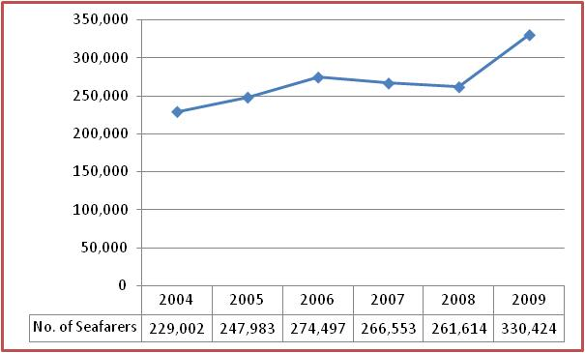

Deployment of Seafarers by Top Ten Occupations: 2007-2009

Occupation | 2007 | 2008 | 2009
- Able Seaman | 31,818 | 34,563 | 45,338
- Oiler | 19,491 | 20,941 | 27,483
- Ordinary Seaman | 17,355 | 18,715 | 23,737
- Chief Cook | 7,778 | 9,022 | 12,651
- Second Mate | 7,873 | 8,694 | 12,119
- Bosun | 7,737 | 8,603 | 11,555
- Messman | 7,810 | 8,320 | 10,536
- Third Engine Officer | 7,056 | 7,995 | 11,307
- Third Mate | 6,559 | 7,349 | 9,857
- Second Engine Officer | 6,369 | 6,878 | 9,557
SUB- TOTAL | 119,846 | 131,080 | 174,140
Other Occupations | 107,054 | 113,064 | 155,588
TOTAL | 226,900 | 244,144 | 329,728
Source:
Philippine Overseas Employment Administration

Deployment of Seafarers by Flags of Registry, 2007 - 2009

Flag of Registry | Seafarers Deployed
Flag of Registry | 2007 | 2008 | 2009
Panama | 51,619 | 53,912 | 67,361
Bahamas | 29,681 | 29,177 | 36,054
Liberia | 21,966 | 21,632 | 29,796
Marshall Island | 9,772 | 11,859 | 18,068
Singapore | 10,308 | 12,130 | 15,674
Malta | 7,513 | 11,025 | 14,786
Norway | 8,188 | 8,883 | 11,447
United Kingdom | 8,172 | 8,232 | 10,313
Cyprus | 7,052 | 7,446 | 9,425
Netherlands | 7,017 | 7,796 | 9,281
SUB-TOTAL | 161,288 | 172,092 | 222,205
Other Flags of Registry | 65,612 | 72,052 | 107,523
TOTAL | 226,900 | 244,144 | 329,728
Source:
Philippine Overseas Employment Administration

Deployment of Seafarers by Top Ten Vessel Type, 2007 – 2009

Type of Vessel | Seafarers Deployed
Type of Vessel | 2007 | 2008 | 2009
Bulk Carrier | 42,357 | 46,732 | 62,229
Passenger | 47,782 | 44,866 | 61,705
Container | 31,983 | 36,614 | 44,276
Tanker | 25,011 | 24,056 | 30,459
Oil/Product Tanker | 14,462 | 15,702 | 22,366
General Cargo | 10,754 | 11,763 | 14,695
Chemical Tanker | 7,902 | 10,891 | 17,179
Tugboat | 6,610 | 7,205 | 10,347
Pure Car Carrier | 5,743 | 6,398 | 7,918
Gas Tanker | 3,471 | 4,235 | 6,187
SUB-TOTAL | 196,075 | 208,462 | 277,361
Other Types of Vessel | 30,825 | 35,682 | 52,367
TOTAL | 226,900 | 244,144 | 329,728
Source:
Philippine Overseas Employment Administration

Education Profile of Seafarers
(Source: Philippine Global Seafarers: A Profile)

Most seafarer survey respondents had college degree. 47% of them had completed a maritime course – either BS Marine Transport (39.6%) or BS Marine Engineering (7.5%). Those who finished an associate level were 31.8% of the sample while 9.1 finished technical-vocational courses. Some 4% had high school education only.
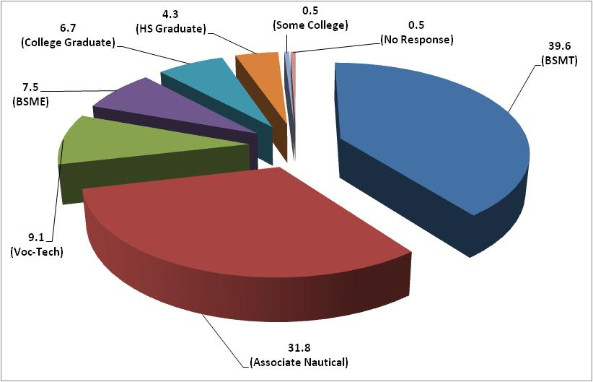

BS Marine Transport | 39.6%
Associate Nautical | 31.8%
Vocational-Technical | 9.1%
BS Marine Engineering | 7.5%
College Graduate | 6.7%
High School Graduate | 4.3%
Some College | 0.5%
No response | 0.5%

Age and Rank of Seafarers, by Education and Job Group (excluding cadets)

Regional Origin and Linguistic Group

- Most seafarers in the sample came from the Bisaya-speaking islands of Cebu, and Bohol (30%), the Ilonggo-speaking islands of Panay and Negros (28%) and 23% from Mindanao where both Bisaya and ilonggo are used.
- All seafarers said they could speak and understand English, and more than 50% said they could read or write it.
- Many speak both Tagalog and Bisaya

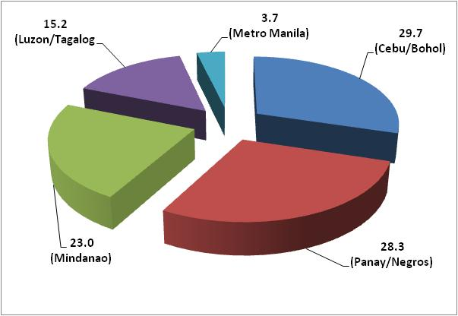

Work Experience and Retirement Age

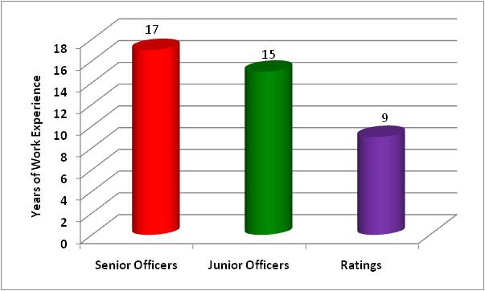
- As one would expect, senior officers had most work experience (17 years), junior officers had 15 years experience, while ratings had nine years.

- Respondents reported their intention of giving up their sea careers on reaching the age of 50. The differences between the ranks were not great: senior officers intended to stop at an average of 52 years, while junior officers declared to stop at 53 years of age. Ratings intended to finish earlier, at 49 years old.

Coastal and Inter-Island Work Experience

- Many seafarers have work experience and training in domestic shipping (41%) before joining the global labor market. Others had work experience in fishing boats and training ships (9%). A few started in domestic ships as deck-boys or cadets (18%); as mess stewards (4%) and as oilers or wipers.

- In between jobs in the global and labor market, only 8.5% of seafarers had shore-based jobs. Few said they look for land-based jobs in between jobs at sea.

- Most seafarers (81.3%) said they had an upward career movement when moving to employment in foreign vessels. Only 15% (mostly ratings) said they had the same job level or job group in both foreign and domestic ships.

Experience with Mixed Nationality Crews

- Seafarers in the survey said that they worked in ships with multinational crews, but mostly with Filipinos aboard. A few said that full Filipino crews are common in the Asian routes.

- Filipino seafarers said they work mostly with vessels commanded by captains or master from Europe (27%); Japan (14%) or the Philippines (14%); and Greece (1%).

- Chief mates and chief engineers were reported mostly from the Philippines (22%); Western Europe (17%); Eastern Europe (Croatia, Ukraine, Poland, Russia), 9%; Japan (9%)

- Junior officers were reported to be mostly from the Philippines (72%); India (5.5%); Baltic States (4.6%)

- Respondents also said that the principal nationality of ratings in their last ship were Filipinos (88%).

UPDATES ON THE “MANILA AMENDMENTS” TO STCW CONVENTION AND CODE

The Philippine Government played host to the 5-day International Maritime Organization’s (IMO) Diplomatic Conference that marked the historic passage of the Manila Amendments to the STCW Convention and Code. It was held on June 21-25 at the Philippine International Convention Center (PICC) gathering some 600 delegates and representatives from member maritime nations and organizations to the first ever major IMO event held outside London. No other than the IMO Secretary-General Efthimios Mitropoulos opened the Conference.

The diplomatic conference paved the way for the adaption of the proposed amendments to the STCW Convention and Code. These changes dubbed as “Manila Amendments” are made to address the inconsistencies and outdated provisions of he Code and to upgrade seafarers’ conditions on boardship.

Some of the major changes contained include the following:

- Revised requirement on hours of work and rest and new requirements for the prevention of drug and alcohol abuse, as well as updated standards relating to medical fitness standards for seafarers (Chapter VIII Standards regarding Watchkeeping, Section A-VIII/1, Fitness for Duty);

- Improved measures to prevent fraudulent practices associated with certificates of competency and strengthen the evaluation process (Regulation 1/5 National Provisions);

- New certification requirements for able seafarers (Regulation II/5 Mandatory minimum requirements for certification of ratings as able seafarer deck and Regulation III/5 Mandatory minimum requirements for certification of ratings as able seafarer engine in a manned engine-room or designated to perform duties in a periodically unmanned engine-room);

- New training and certification requirements for electro-technical officials (Regulation III/6 Mandatory minimum requirements for certification of electro-technical officer);

- Updating of competence requirements for personnel serving on board all types of tankers, including new requirements for personnel serving on liquefied gas tankers (Chapter V, Standards regarding special training requirements for personnel on certain types of ships).

The Manila Amendments will enter into force on January 1, 2010 and into full force five years later (in 2017).

---------------------------------------
Sources/References:

- Philippine Migration and Development Statistical Almanac (PMDSA)
- Philippine Overseas Employment Administration (POEA)
- Seafarers International Research Center (SIRC)
- Maritime Training Council (MTC)
- Manila Bulletin
- Marino: History of the Filipino Seamen
(This is the 30th in a series of essays on the history of the seafaring profession.)
By Roli G. Talampas
- Mr. Maragtas S.V. Amante Study entitled Philippine Global Seafarers: A Profile
- www.planetphilippines.com
- www.philippinestoday.net
- www.aos-world.org

MANPOWER DEMAND

- Sea-based Jobs ( posted in www.workabroad.ph, from January 3 to Mar 1, 2011)

Position | Opening Date | Location | Position | Opening Date | Location
- Bar Utilities  20 vacancies  Experience: 1 year(s) | Mar 1, 2011 | Various Countries | - Second Engineer  2 vacancies  Experience: 1 year(s) | Mar 1, 2011 | Worldwide, Various Countries
- Chief Engineer  5 vacancies  Experience: 1 year(s) | Mar 1, 2011 | Worldwide, Various Countries | - Second Mate  3 vacancies  Experience: 1 year(s | Mar 1, 2011 | Worldwide, Various Countries
- Chief Mate  8 vacancies  Experience: 1 year(s) | Mar 1, 2011 | Worldwide, Various Countries | - Third Engineer  5 vacancies  Experience: 1 year(s) | Mar 1, 2011 | Worldwide, Various Countries
- Electrician  3 vacancies  Experience: 1 year(s) | Mar 1, 2011 | Worldwide, Various Countries | - Third Mate  3 vacancies  Experience: 1 year(s) | Mar 1, 2011 | Worldwide, Various Countries
- Fitter  3 vacancies  Experience: 1 year(s) | Mar 1, 2011 | Worldwide, Various Countries | - Yacht Captain  10 vacancies  Experience: 10 year(s) | Mar 1, 2011 | Qatar, Qatar
- Fourth Engineer  2 vacancies  Experience: 1 year(s) | Mar 1, 2011 | Worldwide, Various Countries | - Fire Fighters  100 vacancies  Experience: 2 year(s) | Feb 28, 2011 | CRUISE LINE, Various Countries
- Kitchen Managers  50 vacancies  Experience: 2 year(s) | Mar 1, 2011 | SEA BASED, Various Countries | - Machinist  100 vacancies  Experience: 2 year(s | Feb 28, 2011 | TANKER / CRUISE, Various Countries
- Marine Mechanic  10 vacancies  Experience: 2 year(s) | Mar 1, 2011 | Qatar, Qatar | - Marine Engineer  70 vacancies | Feb 28, 2011 | CRUISE / TANKER, Various Countries
- Master Mariner  5 vacancies  Experience: 1 year(s) | Mar 1, 2011 | Worldwide, Various Countries | - Marine Mechanic  15 vacancies  Experience: 2 year(s) | Feb 28, 2011 | Qatar, Qatar
- Yacht Captain  10 vacancies  Experience: 5 year(s | Feb 28, 2011 | Qatar, Qatar | - Electrician  8 vacancies  Experience: 5 year(s) | Feb 3, 2011 | FDS 2, South Korea

Position | Opening Date | Location | Position | Opening Date | Location
- Chief/ 1st Engineer  5 vacancies  Experience: 5 year(s) | Feb 25, 2011 | Freeport, Bahama | - HVAC Technician  2 vacancies  Experience: 5 year(s) | Feb 3, 2011 | FDS 2, South Korea
- Hydrographic Surveyor  Experience: 5 year(s) | Feb 15, 2011 | Ras Al Khafji, Saudi Arabia | - Plumber  4 vacancies  Experience: 5 year(s) | Feb 3, 2011 | FDS 2, South Korea
- Meteorological Equipment Technician  Experience: 3 year(s) | Feb 15, 2011 | Ras Al Khafji, Saudi Arabia | - Tugboat Deckhand  8 vacancies  Experience: 5 year(s) | Feb 3, 2011 | PAPUA NEW GUINEA, Papua New Guinea
- Harbour Pilots  20 vacancies  Experience: 3 year(s) | Feb 14, 2011 | United Arab Emirates | - Turner/Lather  4 vacancies  Experience: 5 year(s) | Feb 3, 2011 | FDS 2, South Korea
- Marine Assistant Technicians  4 vacancies  Experience: 5 year(s) | Feb 14, 2011 | ONSHORE,QATAR, Qatar | - Marine Electrician Diesel Mechanic  Experience: 3 year(s) | Feb 1, 2011 | Jeddah, Saudi Arabia
- Marine Mechanic  20 vacancies  Experience: 3 year(s) | Feb 14, 2011 | United Arab Emirates | - Deckhand  2 vacancies  Experience: 3 year(s) | Jan 20, 2011 | Jeddah, KSA, Saudi Arabia
- Tug Engineer  20 vacancies  Experience: 3 year(s | Feb 14, 2011 | United Arab Emirates | - Boat Pilot  5 vacancies  Experience: 2 year(s) | Jan 19, 2011 | MANAMA, Bahrain
- Tug Master  20 vacancies  Experience: 2 year(s | Feb 14, 2011 | United Arab Emirates | - Freight Operation Executive  20 vacancies  Experience: 3 year(s) | Jan 5, 2011 | JEDDAH, Saudi Arabia
- DryDocks World  Experience: 2 year(s) | Jan 3, 2011 | Dubai, United Arab Emirates

OTHER WEBSITES TO VISIT

- www.jobsdb,com.ph  - www.bestjobs.ph  - www.philjobnet.ph | - www.trabahophilippines.net  - www.gulfjobsites.com  - www.jobstreet.com.ph  - www.workabroad.com.ph

LABOR SUPPLY AND TVET SITUATIONER

- A total of 7 training regulations (TRs) have been promulgated by the TESDA Board with 116 TVET programs registered under the Unified TVET Program Registration System (UTPRAS).

- Assessed and certified persons total to 88,720 and 86,234, respectively or certification rate of 97%. Most of the maritime programs are offered in all regions except for Deck Seafaring NC III and Engine Seafaring NC III, which are only offered in NCR, IV-A, IV-B, V.

Training Regulations Promulgated by the TESDA Board
(as of December 2010)

Sector | No. of Promulgated TRs | No. of TRs with  Registered Programs
Maritime | 7 | 6
Agriculture and Fishery | 14 | 11
Automotive | 34 | 15
Construction | 45 | 31
Electronics | 9 | 9
Furniture and Fixtures | 1 | 1
Footwear and Leathergoods | 1 | 0
Garments | 2 | 2
Health, Social and Other Community Development Services | 29 | 23
Heating, Ventilation, Airconditioning and Refrigeration | 5 | 4
Information and Communications Technology | 12 | 11
Land Transport/Aviation | 2 | 2
Metals and Engineering | 28 | 24
Processed Food and Beverages | 6 | 3
Pyrotechnics | 1 | 0
Tourism (Hotel and Restaurant) | 17 | 15
Utilities | 5 | 0
Total | 218 | 157

Training Regulations on Maritime Sector Promulgated by the TESDA Board
(as of December 2010)

Qualification Title | Board  Resolution # | Date  Promulgated | Date  Published | Utilized*
Deck Seafaring NC II | 2005-03 | 03/18/05 | 4/30/05 & 5/02/05
Engine Seafaring NC II | 2005-03 | 03/18/05 | 4/30/05 & 5/02/05
Deck Seafaring NC I | 2006-09 | 04/20/06 | 06/01-02/06
Deck Seafaring NC III | 2006-09 | 04/20/06 | 06/01-02/06
Engine Seafaring NC I | 2006-09 | 04/20/06 | 06/01-02/06
Engine Seafaring NC III | 2006-09 | 04/20/06 | 06/01-02/06
Marine Electricity NC II | 2008-23 | 09/19/08 | 10/20/08
* with registered programs

Number of Registered Programs, Persons Assessed and Certified
(as of December 2010)

Qualification Title¹ | No. of Registered Programs² | Regions with Registered Programs² |  |  | Assessed³ | Certified³
Deck Seafaring NC I | 18 | NCR, Caraga, III, IV-A, IV-B, V, VII |  |  | - | -
Deck Seafaring NC II | 46 | NCR, Caraga, I, II, III, IV-A, IV-B, V, VI, VII, VIII, IX, X |  |  | - | -
Deck Seafaring NC III | 6 | NCR, IV-A, IV-B, V, |  |  | - | -
Engine Seafaring NC II | 30 | NCR, Caraga, I, II, III, IV-A, IV-B, V, VI, VII, VIII, IX, X |  |  | - | -
Engine Seafaring NC I | 12 | NCR, III, IV-A, IV-B, V, IX |  |  | - | -
Engine Seafaring NC III | 4 | NCR, IV-B, V |  |  | - | -
Marine Electricity NC II | 0 |  |  |  | - | -
TOTAL Total | 116
Deck Rating |  |  |  |  | 50,842 | 49,374
Engine Rating |  |  |  |  | 26,282 | 25,641
Messman, Cook |  |  |  |  | 11,596 | 11,219
TOTAL |  |  |  |  | 88,720 | 86,234
Source:s
1. Promulgated Training Regulations, QSO
2. Compendium of Registered Programs (as of December 2010), TSDO
3. Number of Persons Assessed and Certified by Qualification (as of December 30, 2010), CACO

* Five (5) assessment centers in Metro Manila and five (5) in other regions have been accredited based on TESDA’s Procedures
Manual on Accreditation of Assessment Centers

Directory of Maritime Industry Representative/Participants
C/E Alfredo G. Haboc  President  Philippine Association of Maritime  Training Centers, Inc (PAMTCI)    Room 415, Prudential Bank Building, Plaza Lacson, Sta. Cruz, Manila Tel # (02) 522- 2039 ahaboc@philcamsat.com.ph |  | Mr. Juan Miguel Gavales Gonzales  Business Development Officer  New Simulator Center of the Philippines, Inc.    5/F 2053 Building Edison St., Makati City  Tel # (02) 893-2864  juanmiguelgonzales@yahoo.com
Capt. Diofonce F. Tuñacao  Associated Marine Officers’ and Seamen’s  Union of the Philippines (AMOSUP)  Ground Floor, Seamen’s Center Bldg.,  Cabildo corner Sta. Potenciana Streets,  Intramuros, Manila, Philippines, Tel # (02) 527-2110  Leovic68@yahoo.com |  | Ms. Aurita Milanco  Senior Manager  C.F. Sharp Crew Management, Inc. (Manila)    290-292 Casa Rocha Building  General Luna Street Intramuros  Manila Tel # (02) -527-5467 admilanco@cfsharp.com  http://www.cfsharp.com/manning
Mr. Nick Galve  The Maritime Training Council  10th Floor G.E. Antonino Bldg., T.M. Kalaw St.,cor. J. Bocobo Sts. Ermita, Manila  Tel Nos. (02) 527-3977 Local 16, 12 |  | Mr. Mitchelle Fredeluces  Training Manager  Jo Tankers Manila    2/F 1751 Bldg.  1751 Dian St., Palanan  Tel # (02) 860-7568  MitchelleFredeluces@jotankers.com
Mr. Jose Clarito  The Maritime Training Council  10th Floor G.E. Antonino Bldg., T.M. Kalaw St.,cor. J. Bocobo Sts. Ermita, Manila  Tel Nos. (02) 527-3977 Local 16, 12 |  | C/E Christopher P. Maambong  Brilliant Seas Shipping Corporation Manning Agency    U4 11/F, Pearl of the Orient Twr, 1318 Roxas Blvd., Ermita, Manila Tel # (02) 523-8898; Mobile # 0917-577-3490
Capt. Teodoro B. Quijano  Vice President, Internal Affairs  Filipino Association for Mariner’s  Employment (FAME)    12th Floor, MARC 2000 Tower, 1973 Taft Avenue, corner San Andres Street, Malate Manila, 1004 Philippines Tel # (02) 524-7337 / 524-9894 Fax: 527-9794  tbq@barko.com.ph; fame@eastern.com.ph; famesec@eastern.com.ph |  | Capt. Vic del Prado  Director  Filipino Association for Mariner’s  Employment (FAME)  12th Floor, MARC 2000 Tower, 1973 Taft Avenue, corner San Andres Street, Malate Manila, 1004 Philippines Tel # (02) 524-7337 / 524-9894 Fax: 527-9794  Mobile #0920-909-0665  vicsdp@yahoo.com; fame@eastern.com.ph; famesec@eastern.com.ph
Mr. Jonathan M. Palma  Filipino Association for Mariner’s  Employment (FAME)  12th Floor, MARC 2000 Tower, 1973 Taft Avenue, corner San Andres Street, Malate Manila, 1004 Philippines Tel # (02) 524-7337 / 524-9894 Fax: 527-9794  jojopalma@bibby.com.ph; fame@eastern.com.ph; famesec@eastern.com.ph |  | Ms. Arlyd Modesto  Secretariat  Filipino Association for Mariner’s  Employment (FAME)  12th Floor, MARC 2000 Tower, 1973 Taft Avenue, corner San Andres Street, Malate Manila, 1004 Philippines Tel # (02) 524-7337 / 524-9894 Fax: 527-9794  Mobile # 0918-5623412  fame@eastern.com.ph; famesec@eastern.com.ph

