
TECHNICAL EDUCATION AND SKILLS DEVELOPMENT AUTHORITY

LABOR MARKET INTELLIGENCE REPORT

Highlights of the
January 2011
Labor Force Survey
and
Profile of Working Children in the Philippines

(These articles were published in the LABSTAT Updates, March 2011, Vol. 15, No. 4 and Vol. 15, No. 5, respectively, of the Bureau of Labor and Employment Statistics)
Office of the Deputy Director General for Sectoral TVET
Planning Office
TESDA Complex, East Service Road, South Superhighway
Taguig City, Metro Manila
Tel. No. (02) 888 5652 ; 817 2675 ; 893 1966
www.tesda.gov.ph

CODE: ST-PO 07-05-2011

HIGHLIGHTS OF THE JANUARY 2011 LABOR FORCE SURVEY

Overview

The labor market situation in January 2011 was essentially unchanged from last year. Modest growth rates occurred in the agricultural, fishery and forestry sector (1.3%) and services sector (1.0%) while industry employment was down (-1.1%). This was accompanied by the decline in fulltime employment (-2.7%) and wage and salary employment (-1.2%). On a positive note, underemployment rate eased slightly from 19.7% to 19.4% over the period. Meanwhile, unemployment rate at 7.4% was about unchanged or not statistically different from last year’s figure of 7.3% while labor force participation rate (LFPR) fell from 64.5% to 63.7%.

The slowdown in employment growth this January is largely attributed to “base effect” as the country registered a robust expansion in employment a year ago of the same period (+1.739 million - the highest in the 2000 Census-based LFS data series) on the back of the simultaneous holding of the national and local elections. Similar record expansion also occurred in the labor force (+1.712 million), full-time employment (+2.018 million) and wage and salary employment (+2.171 million) in January 2010. It should be noted that employment (as well as labor force) in the 2000 Census based LFS data series followed a “boom and bust” cycle where large or unusual expansion in a particular survey round is always followed by a decline in the same survey round in the same period of the following year or vice versa.

Labor force participation rate (LFPR) in January 2011 fell to 63.7% from 64.5% a year earlier. Fewer persons (383,000) entered or rejoined the labor market compared with the same period last year (1.712 million). The decline was most pronounced among women (50.7% to 49.15) and persons between the age groups 45-54 (80.1% to 78.5%) and 65 years old and over (38.8% to 37.3%). (please refer to Table 4a)

The number of persons in the labor force rose slightly from 38.828 million to 39.211 million over the period, along with the 1.324 million increase in household population 15 years old and over which now stood at 61,532 million.

Table 1- Key Employment Indicators Philippines January 2010 – 2011
(in thousands except rates)

Indicator | January 2011^{p} | January 2010 | Year-on-Year Change
Household population  15 years old and over | 61,532 | 60,208 | 1,324
Labor Force | 39,211 | 38,828 | 383
- Employed persons | 36,293 | 36,001 | 292
- Unemployed persons | 2,919 | 2,827 | 92
- Underemployed persons | 7,054 | 7,107 | -53
- Visibly underemployed | 4,445 | 4,174 | 271
Not in the Labor Force | 23,321 | 21,830 | 941
Labor Force Participation Rate | 63.7 | 64.5
Unemployment rate (%) | 7.4 | 7.3
Underemployment rate (%) | 19.4 | 19.7
- Visible underemployment rate | 12.2 | 11.6
Mean hours of work | 41.0 | 42.3
^{p} preliminary
Source of data: National Statistics Office, Labor Force Survey

Employment

Employment growth slowed down considerably to just 0.8% (+292,000) in January 2011 from the robust 5.1% (+1.739 million) registered a year ago of the same period. The 2010 employment grew at its fastest pace since 2002 at the back of the synchronized national and local elections that boosted the economy and the labor market.

Year | Employment  (‘000) | Increment  (‘000) | Year-on-Year Growth Rate (%)
January 2007 | 33,545 | 1,514 | 4.7
January 2008 | 33,693 | 148 | 0.4
January 2009 | 34,262 | 569 | 1.7
January 2010 | 36,001 | 1,739 | 5.1
January 2011 | 36,293 | 292 | 0.8

- Services sector employment growth managed to remain positive through at a modest 1.1% (+199,000). Growth was mixed across sub-sectors with gains in wholesale and retail trade (+208,000); real estate, renting and business activities (+75,000); transport, storage and communications (+70,000); education (+66,000); and financial intermediation (+64,000). These offset losses in private households with employed persons (-181,000); other community, social and personal service activities (-44,0000); hotels and restaurants (-41,000); public administration (-17,000); and health and social work (-2,000). (please refer to Table 2)

Table 2 - Summary Statistics on Employment Philippines: January 2009, 2010, 2011
(in thousands except rates)

Indicator | 2011^{p} | 2010 | 2009 | Increment |  | Year-on-Year Growth Rate (%)
 |  |  |  | 2010-2011 | 2009-2010 | 2010-2011 | 2009-2010
Employed Persons Sector | 36,293 | 36,001 | 34,262 | 292 | 1,739 | 0.8 | 5.1
Agriculture, Fishery and Forestry | 11,958 | 11,806 | 11,846 | 152 | -40 | 1.3 | -0.3
Agriculture, Hunting and Forestry | 10,536 | 10,351 | 10,446 | 185 | -95 | 1.8 | -0.9
Fishing | 1,422 | 1,455 | 1,400 | -33 | 55 | -2.3 | 3.9
Industry | 5,264 | 5,322 | 4,856 | -58 | 466 | -1.1 | 9.6
Mining and Quarrying | 184 | 193 | 152 | -9 | 41 | -4.7 | 27.0
Manufacturing | 2,953 | 3,009 | 2,849 | -56 | 160 | -1.9 | 5.6
Electricity, Gas and Water | 131 | 157 | 134 | -26 | 23 | -16.6 | 17.2
Construction | 1,996 | 1,963 | 1,721 | 33 | 242 | 1.7 | 14.1
Services | 19,071 | 18,872 | 17,560 | 199 | 1,312 | 1.1 | 7.5
Wholesale and Retail Trade | 7,272 | 7,064 | 6,635 | 208 | 429 | 2.9 | 6.5
Hotels and Restaurants | 1,063 | 1,104 | 988 | -41 | 116 | -3.7 | 11.7
Transport, Storage & Communications | 2,805 | 2,735 | 2,660 | 70 | 75 | 2.6 | 2.8
Financial Intermediation | 448 | 384 | 337 | 64 | 47 | 16.7 | 13.9
Real Estate, Renting & Business Activities | 1,194 | 1,119 | 1,044 | 75 | 75 | 6.7 | 7.2
Public Administration & Defense, Compulsory Social Security | 1,806 | 1,823 | 1,659 | -17 | 164 | -0.9 | 9.9
Education | 1,212 | 1,146 | 1,157 | 66 | -11 | 5.8 | -1.0
Health and Social Work | 430 | 432 | 435 | -2 | -3 | -0.5 | -0.7
Other Community, Social & Personal Service Activities | 905 | 949 | 857 | -44 | 92 | -4.6 | 10.7
Private Households with Employed Persons | 1,933 | 2,114 | 1,785 | -181 | 329 | -8.6 | 18.4
Extra-Territorial Organizations | 3 | 2 | 3 | 1 | -1 | 50.0 | -33.3
STATUS OF EMPLOYMENT
Wage and Salary Workers | 19,848 | 20,082 | 17,911 | -234 | 2,171 | -1.2 | 12.1
Self-employed Workers | 11,035 | 10,573 | 10,725 | 462 | -152 | 4.4 | -1.4
Employers | 1,317 | 1,522 | 1,412 | -205 | 110 | -13.5 | 7.8
Unpaid Family Workers | 4,092 | 3,824 | 4,214 | 268 | -390 | 7.0 | -9.3
REGION
NCR | 4,413 | 4,398 | 4,059 | 15 | 339 | 0.3 | 8.4
CAR | 706 | 701 | 677 | 5 | 24 | 0.7 | 3.5
Region I | 1,906 | 1,882 | 1,866 | 24 | 16 | 1.3 | 0.9
Region II | 1,419 | 1,402 | 1,367 | 17 | 35 | 1.2 | 2.6
Region III | 3,752 | 3,729 | 3,514 | 23 | 215 | 0.6 | 6.1
Region IV-A | 4,572 | 4,490 | 4,222 | 82 | 268 | 1.8 | 6.3
Region IV-B | 1,238 | 1,173 | 1,169 | 65 | 4 | 5 | 5 0.3
Region V | 2,050 | 2,073 | 1,978 | -23 | 95 | -1.1 | 4.8
Region VI | 3,063 | 3,026 | 2,842 | 37 | 184 | 1.2 | 6.5
Region VII | 2,704 | 2,728 | 2,611 | -24 | 117 | -0.9 | 4.5
Region VIII | 1,680 | 1,650 | 1,573 | 30 | 77 | 1.8 | 4.9
Region IX | 1,423 | 1,397 | 1,323 | 26 | 74 | 1.9 | 5.6
Region X | 1,850 | 1,837 | 1,763 | 13 | 74 | 0.7 | 4.2
Region XI | 1,791 | 1,721 | 1,643 | 70 | 78 | 4.1 | 4.7
Caraga | 981 | 958 | 979 | 23 | -21 | 2.4 | -2.1
ARMM | 1,096 | 1,207 | 1,096 | -111 | 111 | -9.2 | 10.1
Note: Details may not add to totals due to rounding of figures.
^{p} Preliminary.
Source of data: National Statistics Office, Labor Force Survey.

- On the other hand, industry employment fell by 1.1% (-58,000) following strong recovery last year (+9.6% or 466,000). With the exception of construction which posted an increase (+33,000), losses occurred in manufacturing (-56,000); electricity, gas and water (-26,000); and mining and quarrying (-9,000).

- In contrast, employment in agriculture, hunting and forestry sector managed to post a slight recovery (+1.8% or +185,000) from the decline a year ago (-0.9 or 95,000) due to the effect of the El Niño weather phenomenon. Meanwhile, employment in the fishery sector dipped by 2.3% (-33,000).

- Strong “base effect” was also observed for full-time employment and wage and salary employment. Both indicators recorded substantial gains last year (+2.018 million and +2.171 million, respectively) but suffered losses this year (-618,000) and -234,000, respectively).

- Meanwhile, employment increases occurred for the following categories of workers: persons in part-time employment (7.0% or +859,000), self-employed workers (+462,000), and unpaid family workers (+268,000).

- Employment losses were recorded in Region V (-23,000), Region VII (-24,000) and ARMM (-111,000). The rest of the regions post4ed gain in employment with the highest in Region IV-A (+82,000), Region XI (+70,000) and Region IV-B (+65,000).

Underemployment

- The number of employed persons who wanted or expressed the desire for additional hours of work fell slightly by 53,000 to 7.054 million. This figure corresponds to 19.4% of total employed, down from 19.7% a year before. (please refer to Table 3)

- Persons who worked less than 40 hours during the reference week and wanting additional hours of work (time-rated underemployment) increased over the period by 271,000 to 4.445 million.

Table 3 - Summary Statistics on Underemployment Philippines: January 2010 and 2011
(in thousands except rate)

Indicator | 2011^{p} | 2010 | Increment
Underemployed Persons | 7,054 | 7,107 | -53
Industry
Agriculture | 3,162 | 3,316 | -154
Industry | 1,043 | 1,015 | 26
Services | 2,849 | 2,776 | 73
Underemployment rate (%) | 19.4 | 19.7 | -0.3
Visible underemployment rate (%)¹ | 12.2 | 11.6 | 0.6
Note: Details may not add to totals due to rounding of figures.
^{p} Preliminary.
1 Includes number of underemployed persons who were with jobs but did not work during the reference period.
Source of data: National Statistics Office, Labor Force Survey.

Unemployment

- The January 2011 unemployment rate at 7.4% was up marginally by 0.1 percentage point from last year. Note that this figure is not statistically different from the rate recorded in January 2010 at 7.3%. In absolute terms, the total number of unemployed persons rose by 92,000 to 2.919 million.

- Nearly half (48.9% or 1.427 million of the total unemployed workforce were young workers (aged 15 to 24 years old). Youth unemployment rate at 17.2% was more than twice the national average. This rate was about the same last year. (please refer to Table 4)

- About three in every five unemployed were men (1,829 million or 62.7%). Compared with last year, unemployment rate of men was down by 0.2 percentage point to 7.6% while the rate for women was up by 0.7% percentage point to 7.2%.

- The majority (47.0% or 1.373 million) were high school graduates or undergraduates. Equally large were college undergraduates and graduates (39.1% or 1.141 million).



Table 4 - Summary Statistics on Unemployment Philippines: January 2010 and 2011
(in thousands except rates/percent)

Indicator | Total Unemployed Persons |  | Percent Share (%) |  | Unemployment Rate (%) |  | Increment
Indicator | 2011^{P} | 2010 | 2011^{P} | 2010 | 2011^{P} | 2010 | Increment
Total | 2,919 | 2,827 | 100.0 | 100.0 | 7.4 | 7.3 | 92
Sex
Men | 1,829 | 1,828 | 62.7 | 64.7 | 7.6 | 7.8 | 1
Women | 1,090 | 999 | 37.3 | 35.3 | 7.2 | 6.5 | 91
Age Group
15-24 years old | 1,427 | 1,456 | 48.9 | 51.5 | 17.2 | 17.8 | -29
25-54 years old | 1,384 | 1,255 | 47.4 | 44.4 | 5.4 | 4.9 | 129
55 years old and over | 107 | 117 | 3.7 | 4.1 | 2.1 | 2.3 | -10
Highest Grade Completed
No grade completed | 8 | 19 | 0.3 | 0.7 |  |  | -11
Elementary | 397 | 419 | 13.6 | 14.8 |  |  | -22
Undergraduate | 180 | 208 | 6.2 | 7.4 |  |  | -28
Graduate | 217 | 211 | 7.4 | 7.5 |  |  | 6
High School | 1,373 | 1,321 | 47.0 | 46.7 |  |  | 52
Undergraduate | 349 | 386 | 12.0 | 13.7 |  |  | -37
Graduate | 1,024 | 935 | 35.1 | 33.1 |  |  | 89
College | 1,141 | 1,068 | 39.1 | 37.8 |  |  | 73
Undergraduate | 577 | 547 | 19.8 | 19.3 |  |  | 30
Graduate | 564 | 521 | 19.3 | 18.4 |  |  | 43

- Six regions posted unemployment rates higher that the national rate: NCR (12.05), Region I (10.0%), Region III (7.9%), Region IV-A (9.5%), Region VII (8.2%) and Caraga (7.5%). (please refer to Table 5)

- Compared with last year, notable increases in unemployment rates occurred in Region I (+2.1 percentage points) and NCR (+1.2 percentage points) while notable reductions occurred in Region III (-1.1 percentage points), Region IX (-1.5 percentage points) and Region XII (-2.0 percentage points).

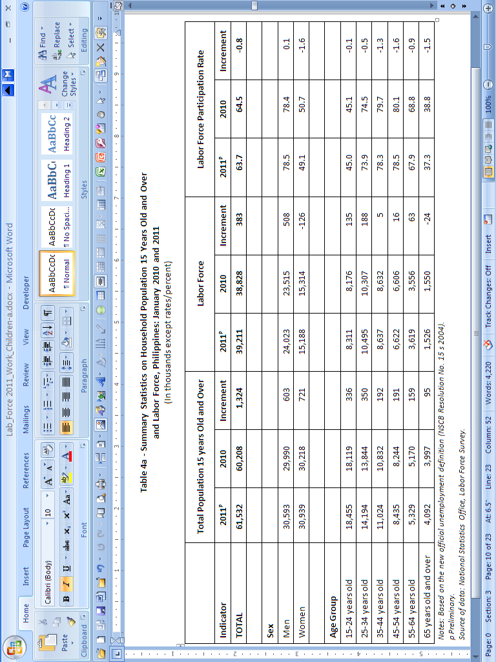

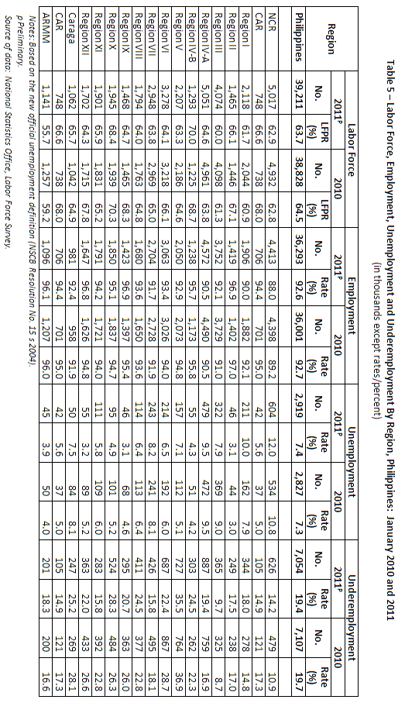

Profile of Working Children in the Philippines

Overview

The issue on the eradication of child labor has always been paramount in the consciousness not only within countries but also to the international community as a whole. Positive experiences on child labor programs from many parts of the world combined with hard-line stance and strong commitment among different international organizations have begun to bring teeth to anti-child labor advocacy.

However, the International Labor Organization (ILO) stressed, that not all of the work done by children should be eliminated as in some instances their participation in work may even be considered as something positive for as long as it does not hamper their health and personal development. Hence, Article 7 of ILO Convention No. 138 stipulated that children in particular age groups are permitted to engage in such “light work.”

In the Philippines, a child’s employment or participation in public entertainment or information through cinema and other forms of media is allowed provided that such employment is essential and that the contract is concluded by the child’s parents or legal guardian in order to ensure the child’s protection. However, there are no existing data series on child labor. What is available are data on working children in which child labor is a part of.

The term “working children” is a broad concept which encompasses most production activities undertaken by the children, paid or unpaid, for a few hours or full time, on a casual or regular basis, in the organized or unorganized (formal or informal) sector, and whether the activities are legal or illegal. Work in family enterprises and in household-based production activities is included, so is work done in another household for an employer.

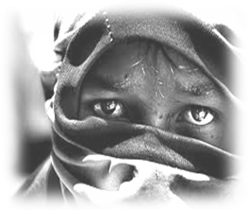
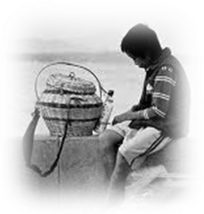
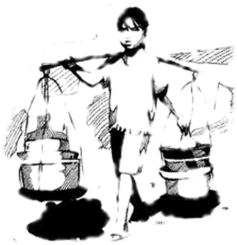
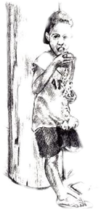

Using the Public Use Files of the Labor Force Survey of the National Statistics Office from 2004 to 2009, the LABSTAT Updates aims to provide an analysis and profile of the working children, defined to cover those aged 5-17 years old, in the Philippines. Specifically, it will highlight on the demographic and socioeconomic profile of working children in order to get a glimpse on who and where these Filipino working children are.

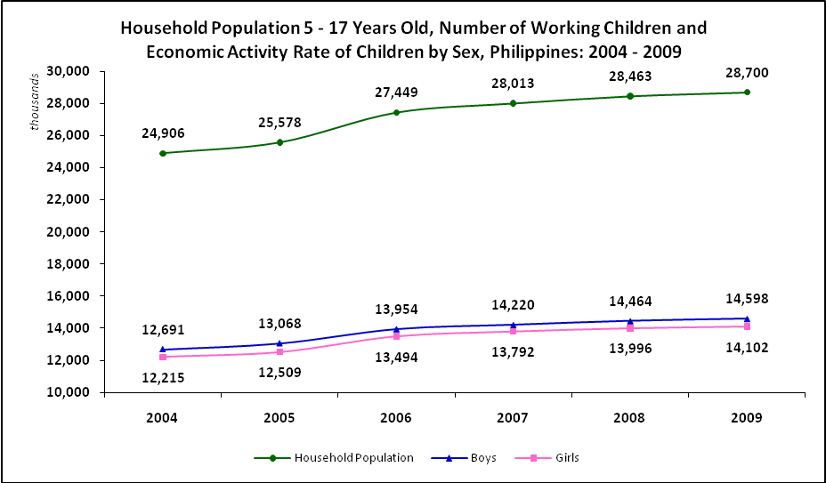
Source of basic data: National Statistics Office, Labor Force Survey, Public Use Files

- The household population of children for both sexes generally followed an increasing trend from 2004 - 2009.
- However, the boys aged 5-17 years old consistently posted a higher population than the girls of the same age during the same period.

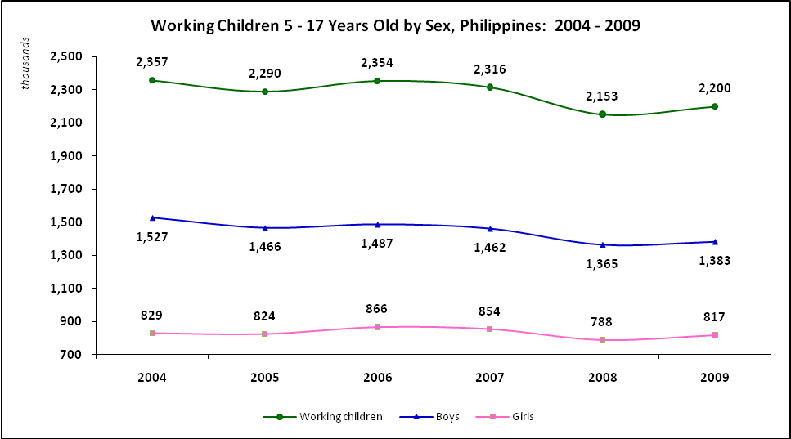
Source of basic data: National Statistics Office, Labor Force Survey, Public Use Files
- In contrast, the phenomenon of working children showed a fluctuating trend over the years. In 2009, it went down to 2.2 million or by 6.7% from 2.4 million in 2004.

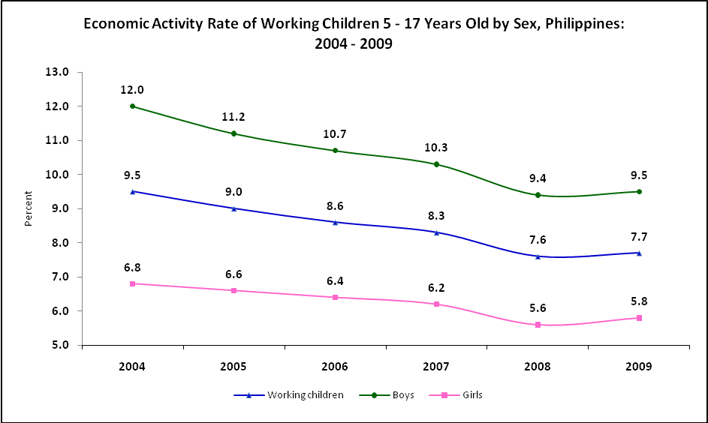
Source of basic data: National Statistics Office, Labor Force Survey, Public Use Files
- The economic activity rate of children or the proportion of working children to the total population of children in the country decreased from 9.5% in 2004 to 7.7% in 2009.

- However, the decline in economic activity rate for working boys was faster (12.0% to 9.5%) compared to their girl counterparts (6.8% to 5.8%).

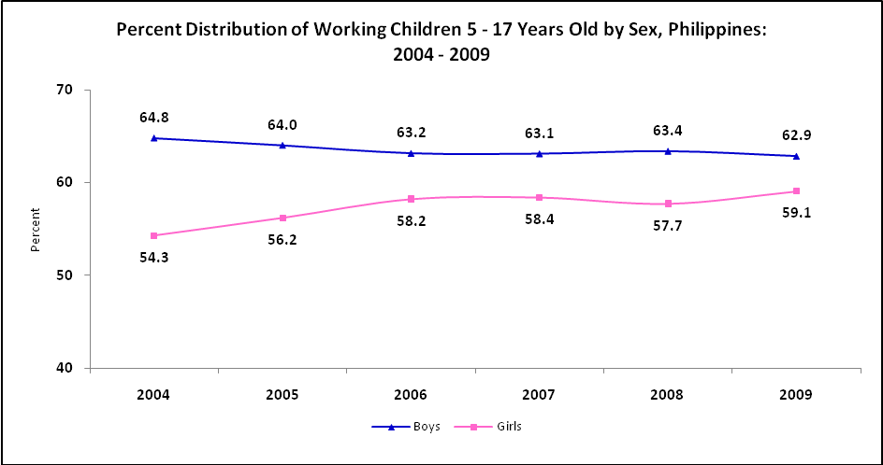
Source of basic data: National Statistics Office, Labor Force Survey, Public Use Files
- Boys still make up more than half of the total number of working children. Their share ranged from a high of 64.8% in 2004 to 62.9% in 2009.
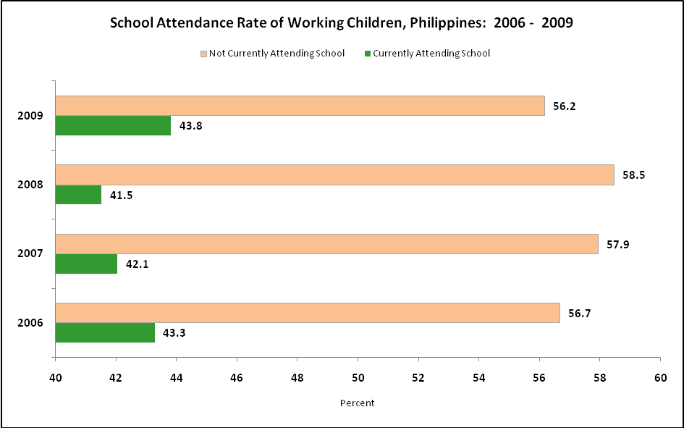
Source of basic data: National Statistics Office, Labor Force Survey, Public Use Files
- Generally, six out of 10 working children did not attend school. Those currently attending school were highest in 2009.

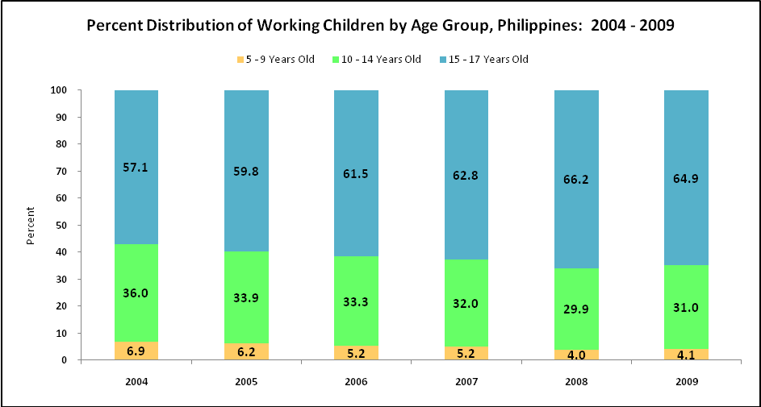
Source of basic data: National Statistics Office, Labor Force Survey, Public Use Files
- Older children are more likely to be working compared to their younger counterparts. For 2009, almost two thirds (64.9%) of working children were aged 15-17 years old, while 31.6% and 4.1% were 10-14 years old and 5-9 years old, respectively

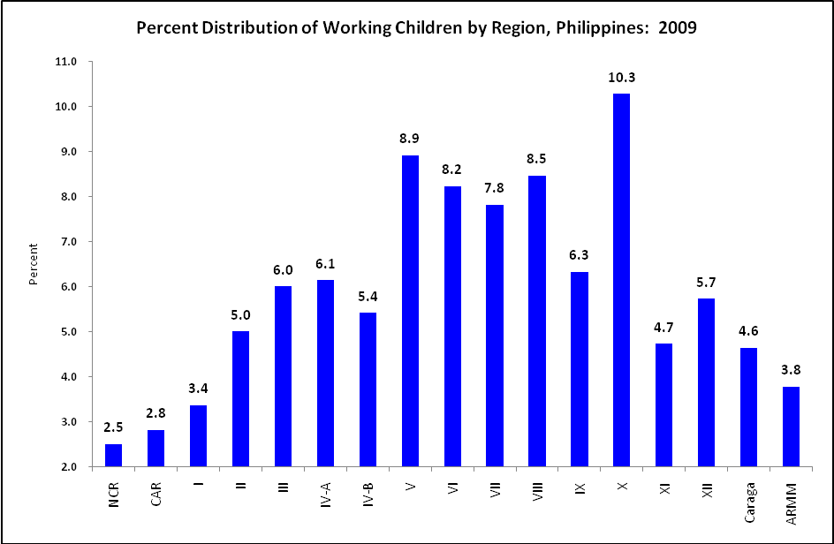
Source of basic data: National Statistics Office, Labor Force Survey, Public Use Files
- Region X (Northern Mindanao) posted the biggest share of the total working children in the country in 2009 at 10.3%.

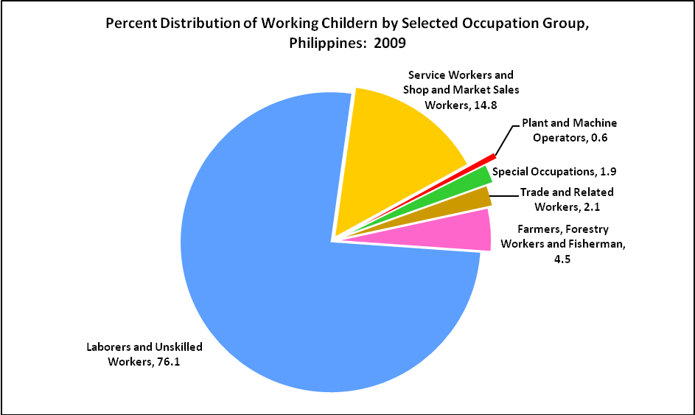
Source of basic data: National Statistics Office, Labor Force Survey, Public Use Files
- Working children were predominantly laborers and unskilled workers, comprising more than three-fourths (76.1%) of the total in 2009.

Top Three Industries in terms of the number of working children in 2009
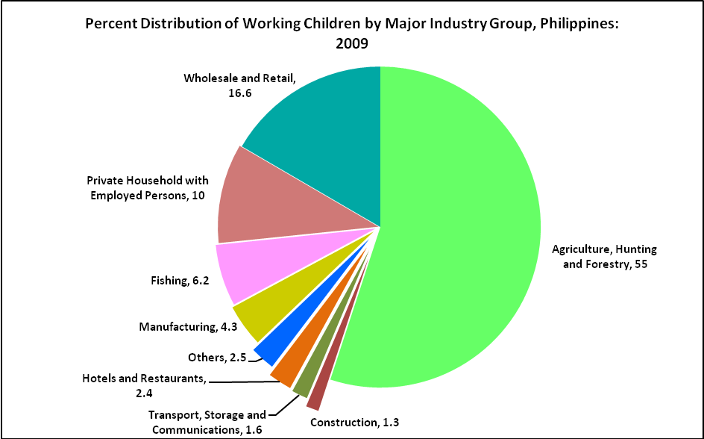
Source of basic data: National Statistics Office, Labor Force Survey, Public Use Files
- Agriculture, hunting and forestry employed more than half (55.0%) of the total working children in 2009.

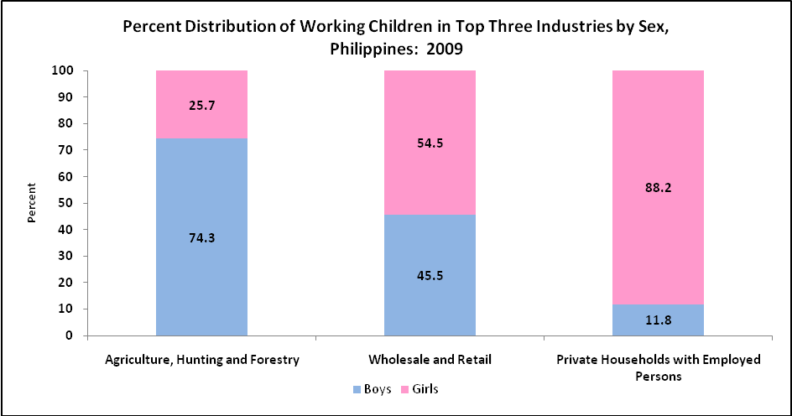
Source of basic data: National Statistics Office, Labor Force Survey, Public Use Files
- A great proportion of boys worked in farms (74.3%) while girls dominated the private households industry (88.2%) and wholesale and retail trade (54.5%).

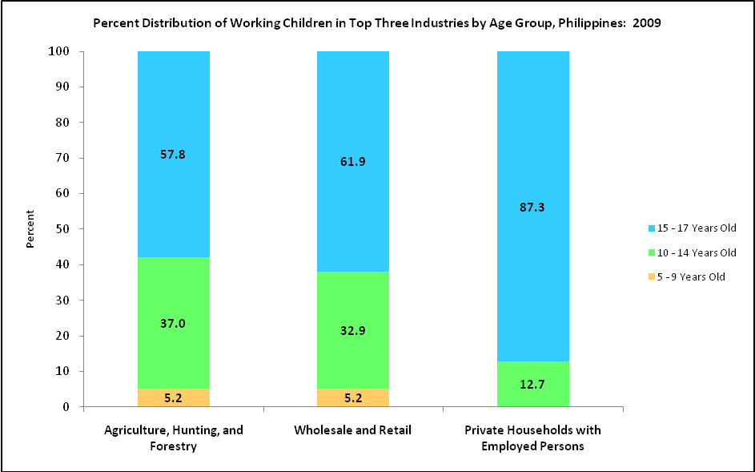
Source of basic data: National Statistics Office, Labor Force Survey, Public Use Files
- Older children with ages ranging from 15 – 17 years old dominated the top three industries in 2009. In private households, they comprised about 90% of the total.

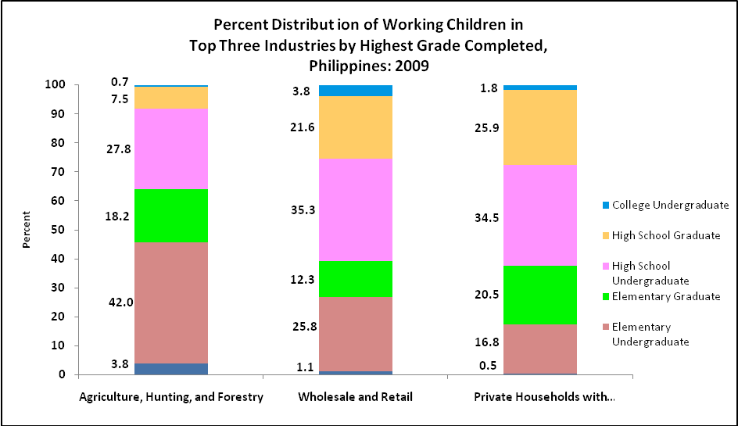
Source of basic data: National Statistics Office, Labor Force Survey, Public Use Files
- Majority of children working in wholesale and retail were better educated than those working in agriculture. Most of the working children in agriculture were elementary undergraduates (42.0%) while 56.9% and 60.4% of children in wholesale and retail trade; and private households reached high school, respectively.

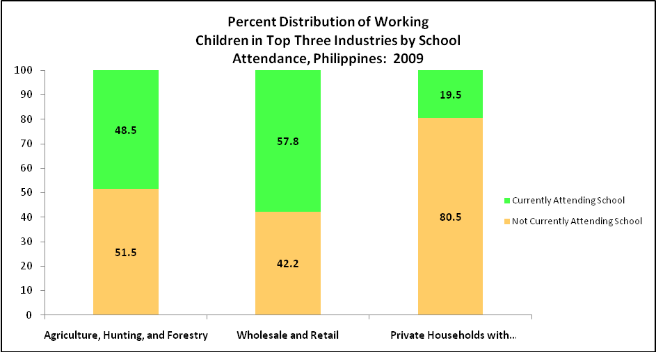
Source of basic data: National Statistics Office, Labor Force Survey, Public Use Files
- Four (4) in every 5 children working in private households in 2009 were not attending school, while 3 out of 5 in wholesale and retail trade were attending school.

Household Population 5 - 17 Years Old, Number of Working Children and
Economic Activity Rate of Children by Sex, Philippines: 2004 - 2009
(In Thousands Except Rates)

YEAR AND SEX | Household Population | Working Children | Economic Activity Rate
Both Sexes
2004 | 24,906 | 2,357 | 9.5
2005 | 25,578 | 2,290 | 9.0
2006 | 27,449 | 2,354 | 8.6
2007 | 28,013 | 2,316 | 8.3
2008 | 28,463 | 2,153 | 7.6
2009 | 28,700 | 2,200 | 7.7
Boys
2004 | 12,691 | 1,527 | 12.0
2005 | 13,068 | 1,466 | 11.2
2006 | 13,954 | 1,487 | 10.7
2007 | 14,220 | 1,462 | 10.3
2008 | 14,464 | 1,365 | 9.4
2009 | 14,598 | 1,383 | 9.5
Girls
2004 | 12,215 | 829 | 6.8
2005 | 12,509 | 824 | 6.6
2006 | 13,494 | 866 | 6.4
2007 | 13,792 | 854 | 6.2
2008 | 13,996 | 788 | 5.6
2009 | 14,102 | 817 | 5.8
3
Note: Details may not add up to totals due to rounding.
Source of basic data: National Statistics Office, Labor Force Survey, Public Use Files

Working Children 5 -17 Years Old by Age Group and School Attendance, Philippines: 2004 – 2009

SEX, AGE GROUP and  SCHOOL ATTENDANCE | 2004 | 2005 | 2006 | 2007 | 2008 | 2009
BOTH SEXES | 2,357 | 2,290 | 2,354 | 2,316 | 2,153 | 2,200
5 - 9 Years Old | 162 | 143 | 123 | 120 | 86 | 90
10 - 14 Years Old | 849 | 776 | 783 | 742 | 643 | 682
15 - 17 Years Old | 1,346 | 1,370 | 1,448 | 1,454 | 1,425 | 1,427
BOYS | 1,527 | 1,466 | 1,488 | 1,463 | 1,365 | 1,383
5 - 9 Years Old | 98 | 86 | 73 | 70 | 49 | 52
10 - 14 Years Old | 550 | 496 | 496 | 467 | 401 | 432
15 - 17 Years Old | 880 | 884 | 919 | 926 | 915 | 899
GIRLS | 829 | 824 | 867 | 854 | 787 | 817
5 - 9 Years Old | 64 | 58 | 51 | 50 | 36 | 39
10 - 14 Years Old | 299 | 280 | 287 | 275 | 241 | 250
15 - 17 Years Old | 467 | 487 | 529 | 529 | 510 | 528
SCHOOL ATTENDANCE
Currently Attending School | NA | NA | 1,019 | 974 | 894 | 964
Not Currently Attending School | NA | NA | 1,334 | 1,342 | 1,259 | 1,236
Note: Details may not add up to totals due to rounding.
NA Not Available.
Source of basic data: National Statistics Office, Labor Force Survey, Public Use Files

Working Children 5 - 17 Years Old by Region, Major Industry Group and
Major Occupation Group, Philippines: 2009
(In Thousands)

REGION, MAJOR INDUSTRY GROUP AND MAJOR OCCUPATION GROUP | 2009
PHILIPPINES | 2,200
National Capital Region | 55
Cordillera Administrative Region | 62
Region I - Ilocos Region | 74
Region II - Cagayan Valley | 110
Region III - Central Luzon | 132
Region IV- A - CALABARZON | 135
Region IV- B - MIMAROPA | 119
Region V - Bicol Region | 196
Region VI - Western Visayas | 181
Region VII - Central Visayas | 172
Region VIII - Eastern Visayas | 186
Region IX - Zamboanga Peninsula | 139
Region X - Northern Mindanao | 226
Region XI - Davao Region | 104
Region XII - SOCCSKSARGEN | 126
Caraga | 102
Autonomous Region in Muslim Mindanao | 83
MAJOR INDUSTRY GROUP
Agriculture, Hunting and Forestry | 1,211
Wholesale and Retail Trade, Repair of Motor Vehicles,  Motorcycles, and Personal and Household Goods | 365
Private Households with Employed Persons | 220
Others | 407
MAJOR OCCUPATION GROUP
Service Workers and Shop and Market Sales Workers | 325
Farmers, Forestry Workers and Fishermen | 99
Laborers and Unskilled Workers | 1,675
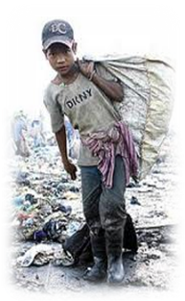  Other Occupations | 101
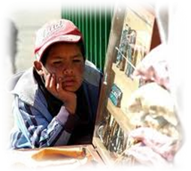
Note: Details may not add up to totals due to rounding.
Source of basic data: National Statistics Office, Labor Force Survey, Public Use Files


Working Children in Top Three Industries with The Most Number of
Working Children by Sex, Age Group, School Attendance and
Highest Grade Completed, Philippines: 2009
(In Thousands)

SEX, AGE, SCHOOL ATTENDANCE AND HIGHEST GRADE COMPLETED | Agriculture, Hunting, and Forestry | Wholesale and Retail Trade, Repair of Motor Vehicles, Motorcycles, and Personal and Household Goods | Private Households with Employed Persons
 | 1,211 | 365 | 220
SEX
Male | 900 | 166 | 26
Female | 312 | 199 | 195
AGE
5 - 9 Years Old | 63 | 19 | 0
10 - 14 Years Old | 448 | 120 | 28
15 - 17 Years Old | 700 | 226 | 192
SCHOOL ATTENDANCE
Currently Attending School | 587 | 211 | 43
Not Currently Attending School | 624 | 154 | 177
HIGHEST GRADE COMPLETED
No Grade Completed | 46 | 4 | 1
Elementary | 729 | 139 | 82
Undergraduate | 509 | 94 | 37
Graduate | 220 | 45 | 45
High School |  | 208 | 134
Undergraduate | 337 | 129 | 76
Graduate | 91 | 79 | 57
College Undergraduate | 9 | 14 | 4
Note: Details may not add up to totals due to rounding.
Source of basic data: National Statistics Office, Labor Force Survey, Public Use Files

Sources:
Bureau of Labor Employment and Statistics, Highlights of January 2011 Labor Force Survey, LABSTAT Updates, Vol. 15, No.4, March 2011

Bureau of Labor Employment and Statistics, Profile of Working Children in the Philippines LABSTAT Updates, Vol. 15, No. 5, March 2011

